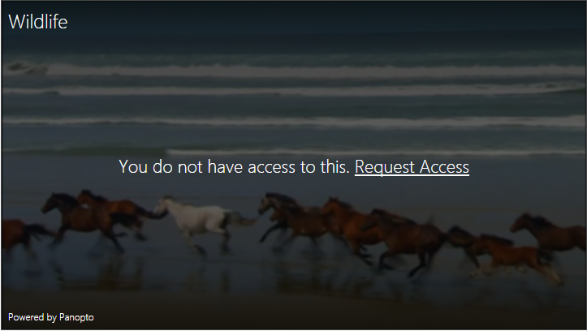

Managing Video Permissions

The Basics

# Sharing Panopto Content in Blackboard

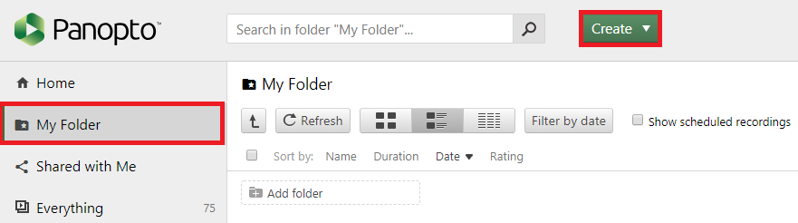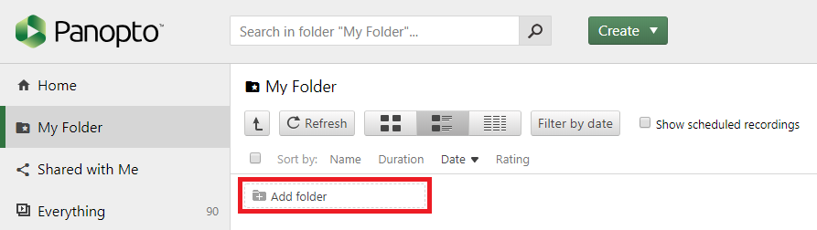

01 Folder Concepts

Understanding folder structure is essential to sharing Panopto video content. All videos are located in folders in Panopto. Folders will have a default level of permissions that are inherited from the initial “Panopto Course Tool” setup in an individual course. For students to have access to video content folder permissions must match the course or be modified to allow viewing.

# Folder Types

* **My Folder** - The “My Folder” is essentially a “Sandbox” where you can create video content that isn’t yet ready for deployment. Videos in this folder are not associated with any course. They will need to be moved into a course folder when you are ready to deploy these videos to a course.
  + This folder can’t be shared.
* **Course Folder** - This folder is automatically created after adding the “Course Application Tool”. The automatically generated folder is associated with the course and section number that you are working in.
  + If you want to share or reuse content between course sections you will need to modify the “Permissions” to reflect all of the courses and sections that you wish to share content with.
  + To share folders you must always modify permissions the original source folder (Where content originated from).
* **Subfolders** - In Panopto it is possible to create subfolders to help organize your video content in a course. Subfolder will inherit their permissions from the parent “Course Folder”.

# All Panopto Video Content is Organized in Folders

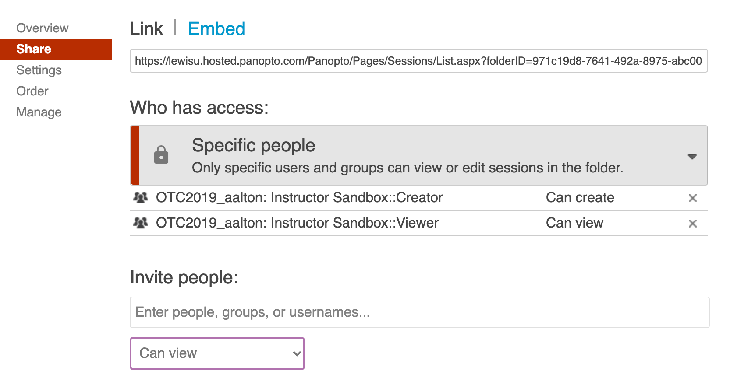

02 Modifying Folder Permissions

# Share Permissions

Once “Share” opens you will see which individuals, groups, or courses have access. This will display as “Who Has Access”.

**Share With an Instructor**

In the “Invite People” type the instructor’s name. Then choose between “Can Create” or “Can View”

**Share With Another Course/Section**

In the “Invite People” type the course name. Be sure that the folder reflects the correct course number and section.

**Understanding Roles**

* + Can Create - Allows users to access and modify video content and deploy
  + Can View - Allows users to view content without the ability to modify any video settings

To grant access or share content folders you must locate the original folder that your content is located in. This is best accomplished by accessing “Panopto” instead of working inside the Blackboard LTI integration.

Once you locate the folder navigate to the right-hand corner under your username and select the “Share” icon

# Access Folder Permissions

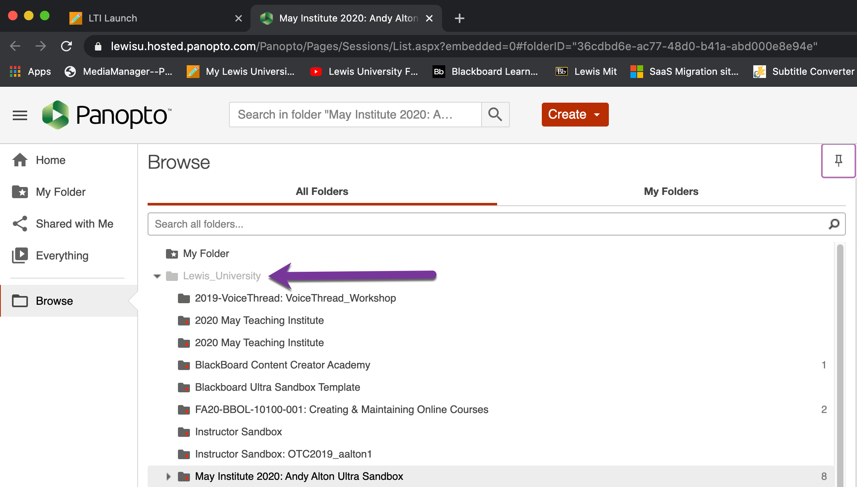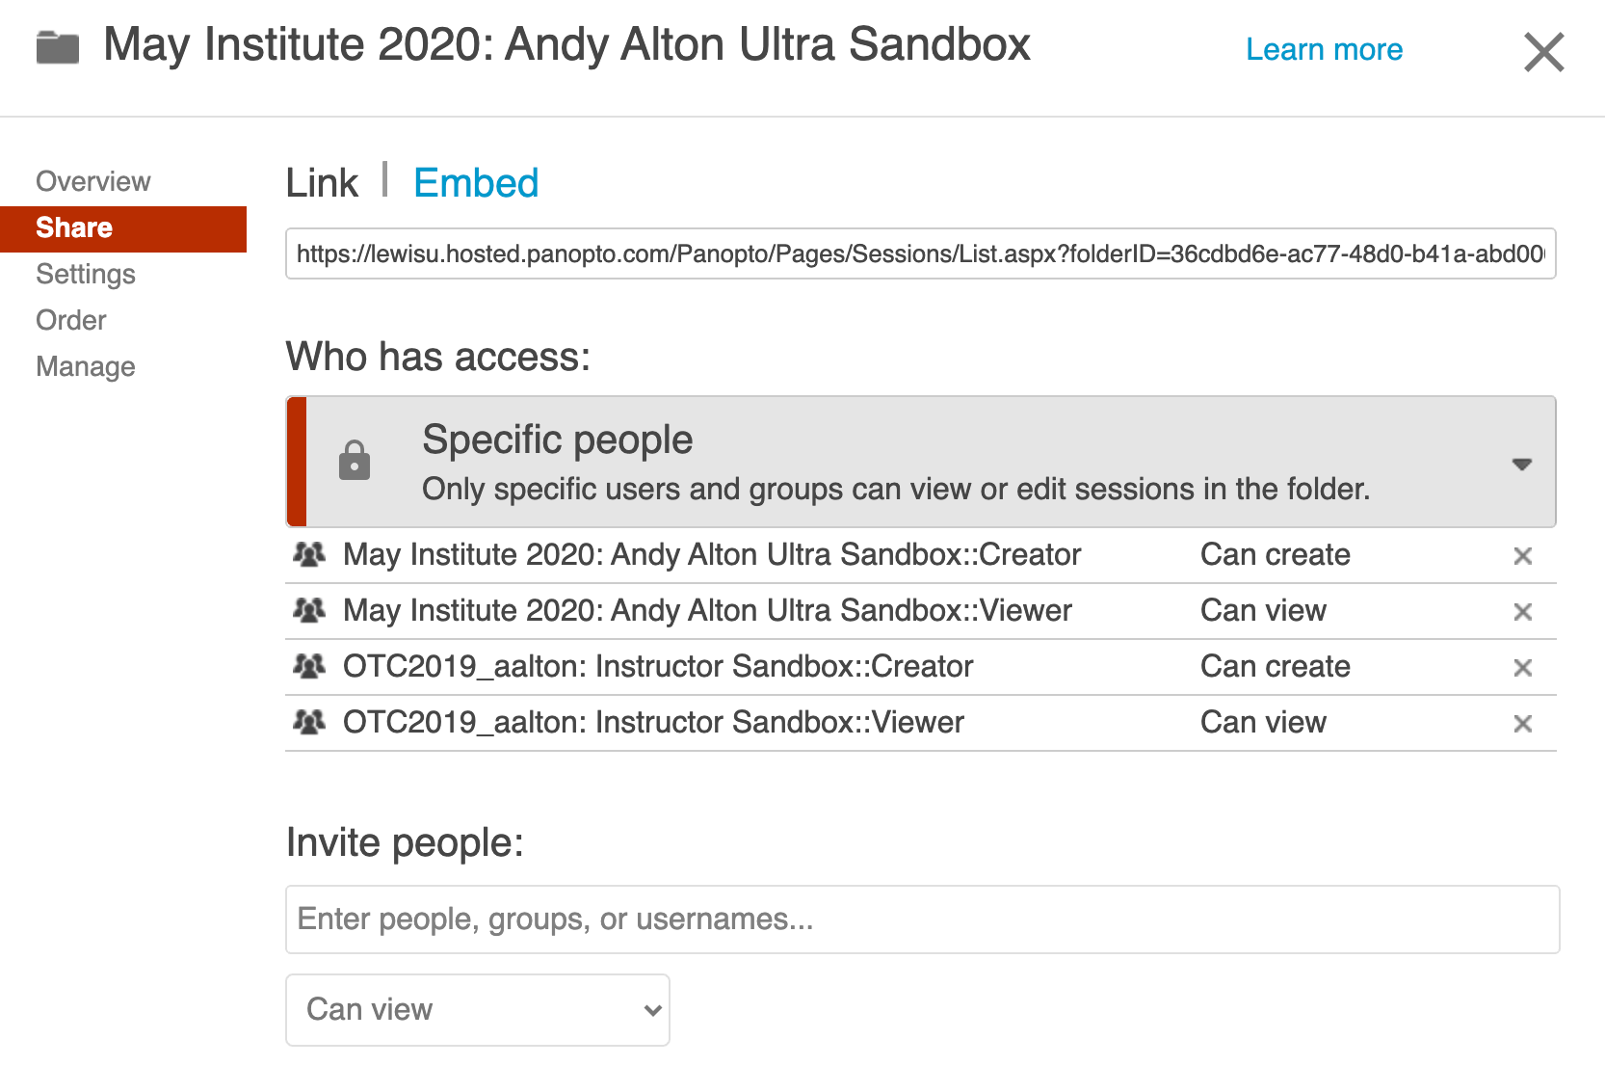

03 Rolling Over Video Content in 3 Easy Steps

# Step 2

* Once the source folder has been selected select the “Share” icon
* Review “Who Has Access”
* Go to “Invite People” and enter the destination course you want to share contents with
* Select “Create” or “View” role

# Step 3

* Verify that the sharing permissions
* The course that you want to share content with should now appear in the “Who Has Access” list
* Check or add video content to rolled over course

# Step 1

* Access Panopto
* In the left menu select “Browse”
* Open the folder “Lewis_University”
* Locate the original course folder where the video content was originally created
* Pin the folder open to see all video content in the source folder